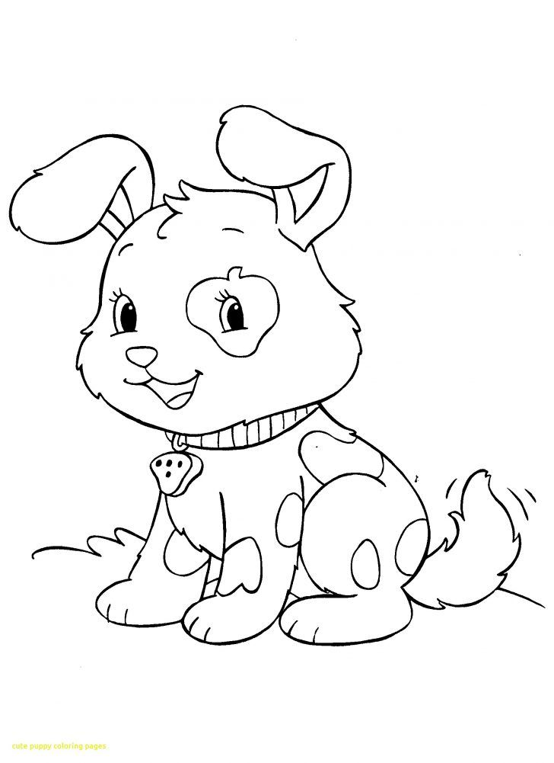
Name__________________________________________________________________________

________________________________________________________________________________________________________________________________________________________________________________________________________________________________________________________________________________________________________________________________________________________________________________________________________________________________________________________________________________________________________________________________________________
Name_________________________________________________________________________
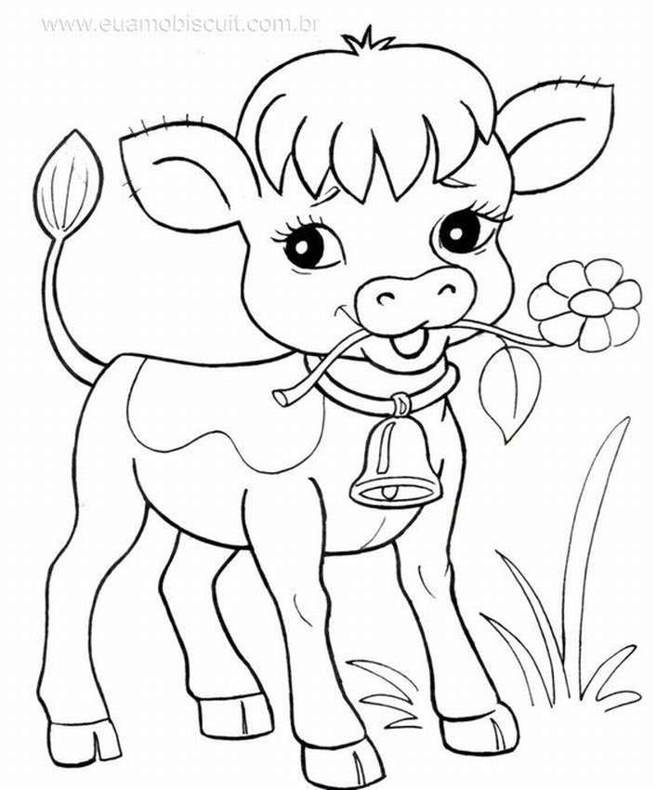

________________________________________________________________________________________________________________________________________________________________________________________________________________________________________________________________________________________________________________________________________________________________________________________________________________________________________________________________________________________________________________________________________________
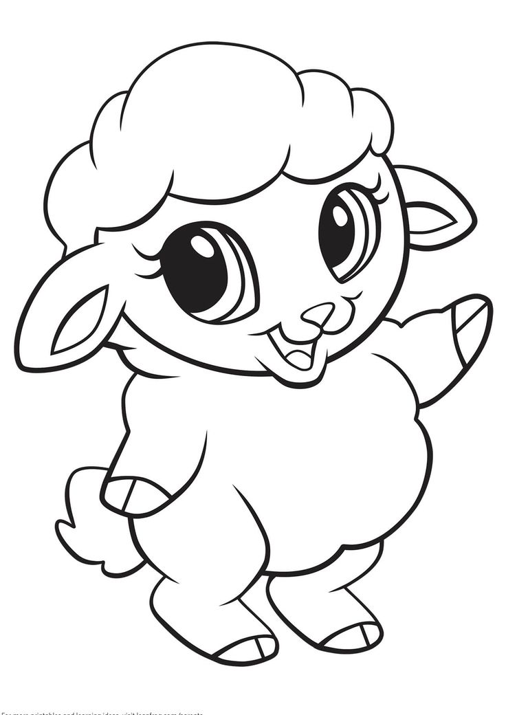
Name_________________________________________________________________________

________________________________________________________________________________________________________________________________________________________________________________________________________________________________________________________________________________________________________________________________________________________________________________________________________________________________________________________________________________________________________________________________________________

Name_________________________________________________________________________

________________________________________________________________________________________________________________________________________________________________________________________________________________________________________________________________________________________________________________________________________________________________________________________________________________________________________________________________________________________________________________________________________________
Name_________________________________________________________________________
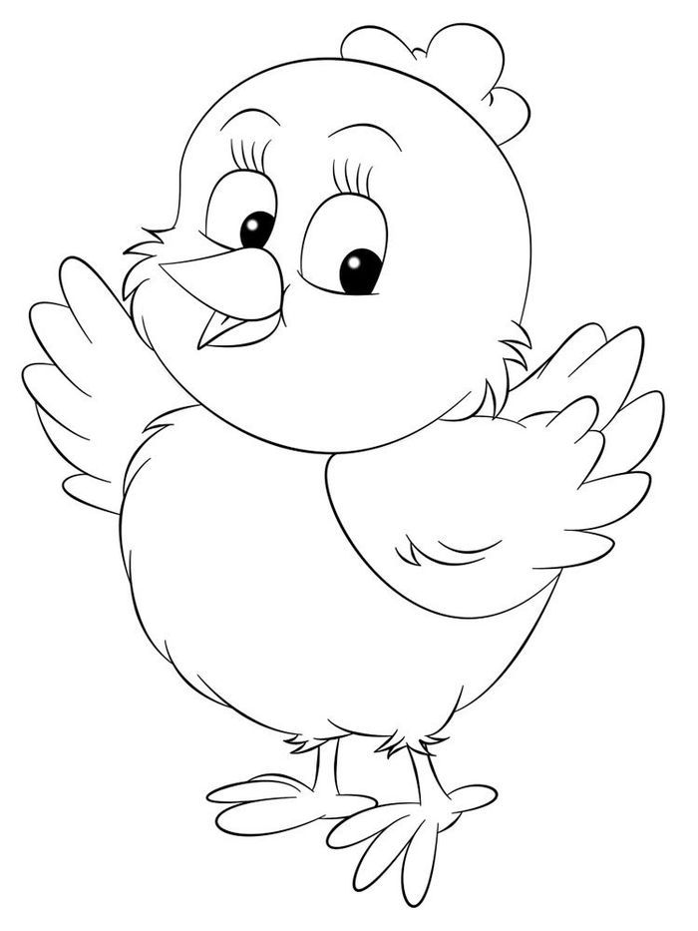

________________________________________________________________________________________________________________________________________________________________________________________________________________________________________________________________________________________________________________________________________________________________________________________________________________________________________________________________________________________________________________________________________________

Name_________________________________________________________________________
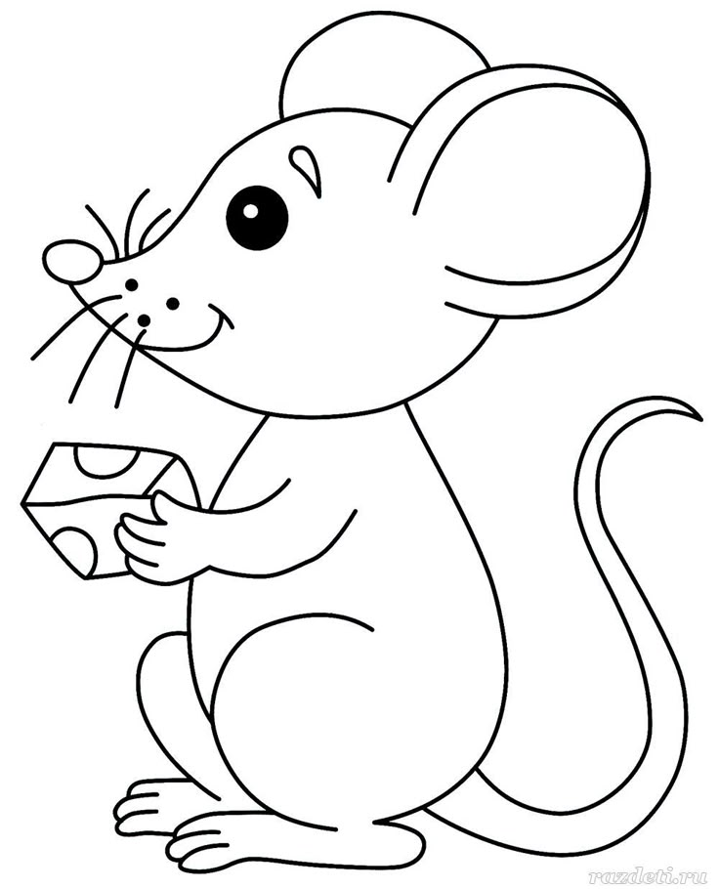

________________________________________________________________________________________________________________________________________________________________________________________________________________________________________________________________________________________________________________________________________________________________________________________________________________________________________________________________________________________________________________________________________________
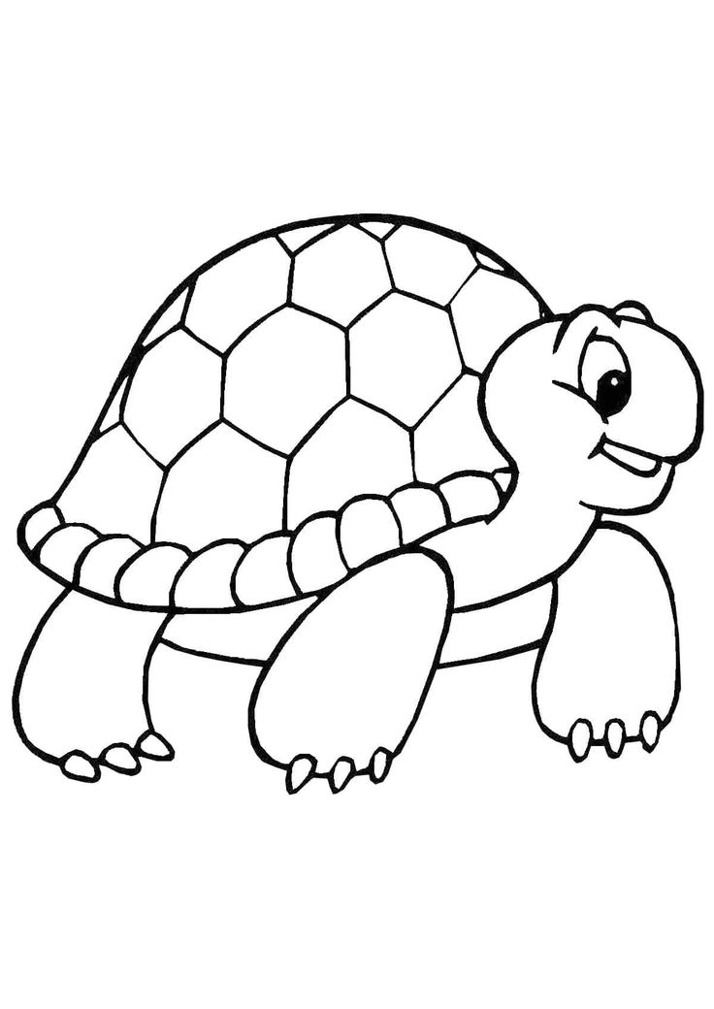
Name_________________________________________________________________________

________________________________________________________________________________________________________________________________________________________________________________________________________________________________________________________________________________________________________________________________________________________________________________________________________________________________________________________________________________________________________________________________________________
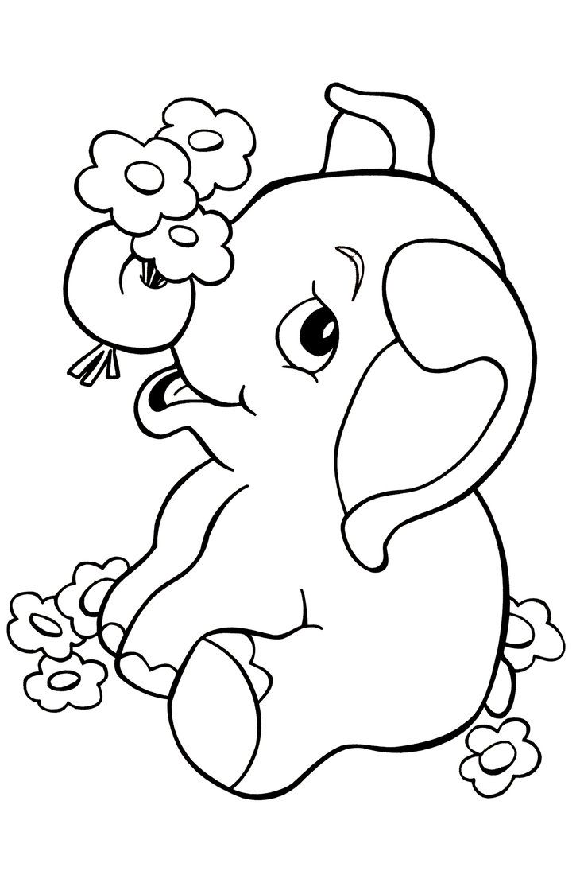
Name_________________________________________________________________________

________________________________________________________________________________________________________________________________________________________________________________________________________________________________________________________________________________________________________________________________________________________________________________________________________________________________________________________________________________________________________________________________________________
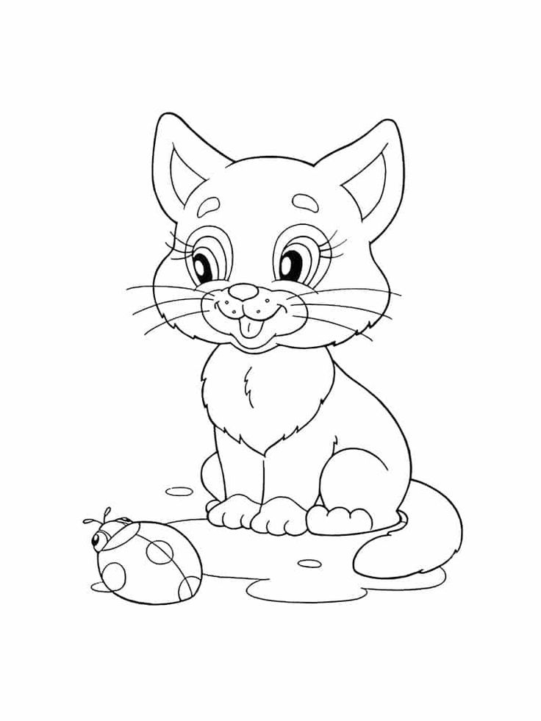
Name_________________________________________________________________________

________________________________________________________________________________________________________________________________________________________________________________________________________________________________________________________________________________________________________________________________________________________________________________________________________________________________________________________________________________________________________________________________________________
Name_________________________________________________________________________
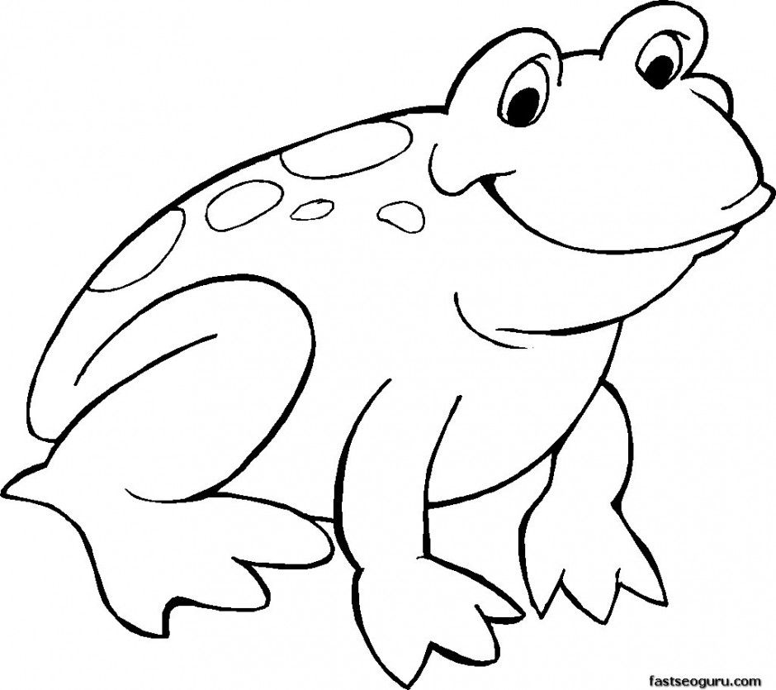

_______________________________________________________________________________________________________________________________________________________________________________________________________________________________________________________________________________________________________________________________________________________________________________________________________________________________________________________________________________________________________________________________________________
Name_________________________________________________________________________
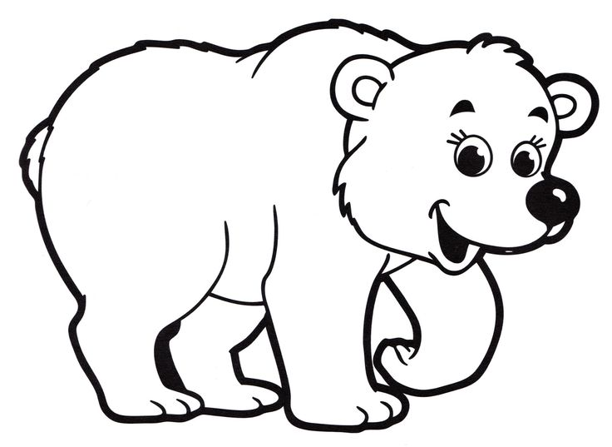

_______________________________________________________________________________________________________________________________________________________________________________________________________________________________________________________________________________________________________________________________________________________________________________________________________________________________________________________________________________________________________________________________________________

Name_________________________________________________________________________
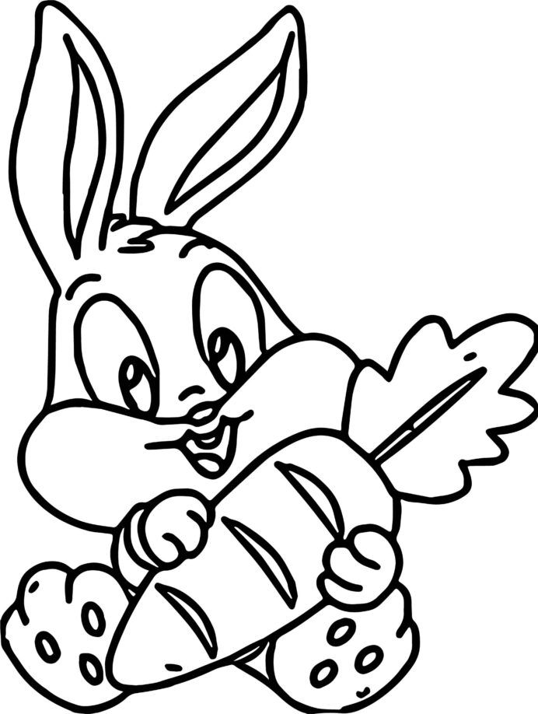

_______________________________________________________________________________________________________________________________________________________________________________________________________________________________________________________________________________________________________________________________________________________________________________________________________________________________________________________________________________________________________________________________________________
Name_________________________________________________________________________
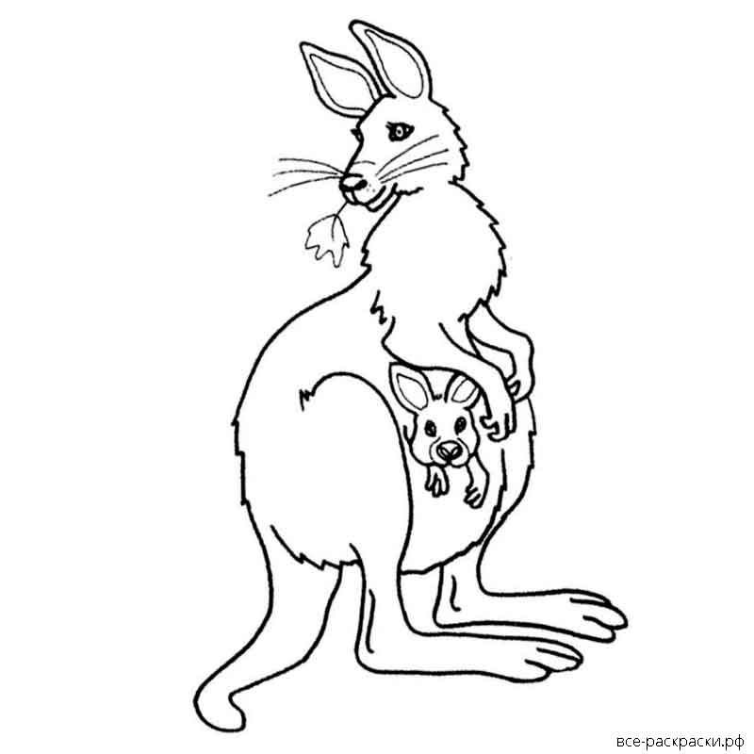

________________________________________________________________________________________________________________________________________________________________________________________________________________________________________________________________________________________________________________________________________________________________________________________________________________________________________________________________________________________________________________________________________________
Name_________________________________________________________________________
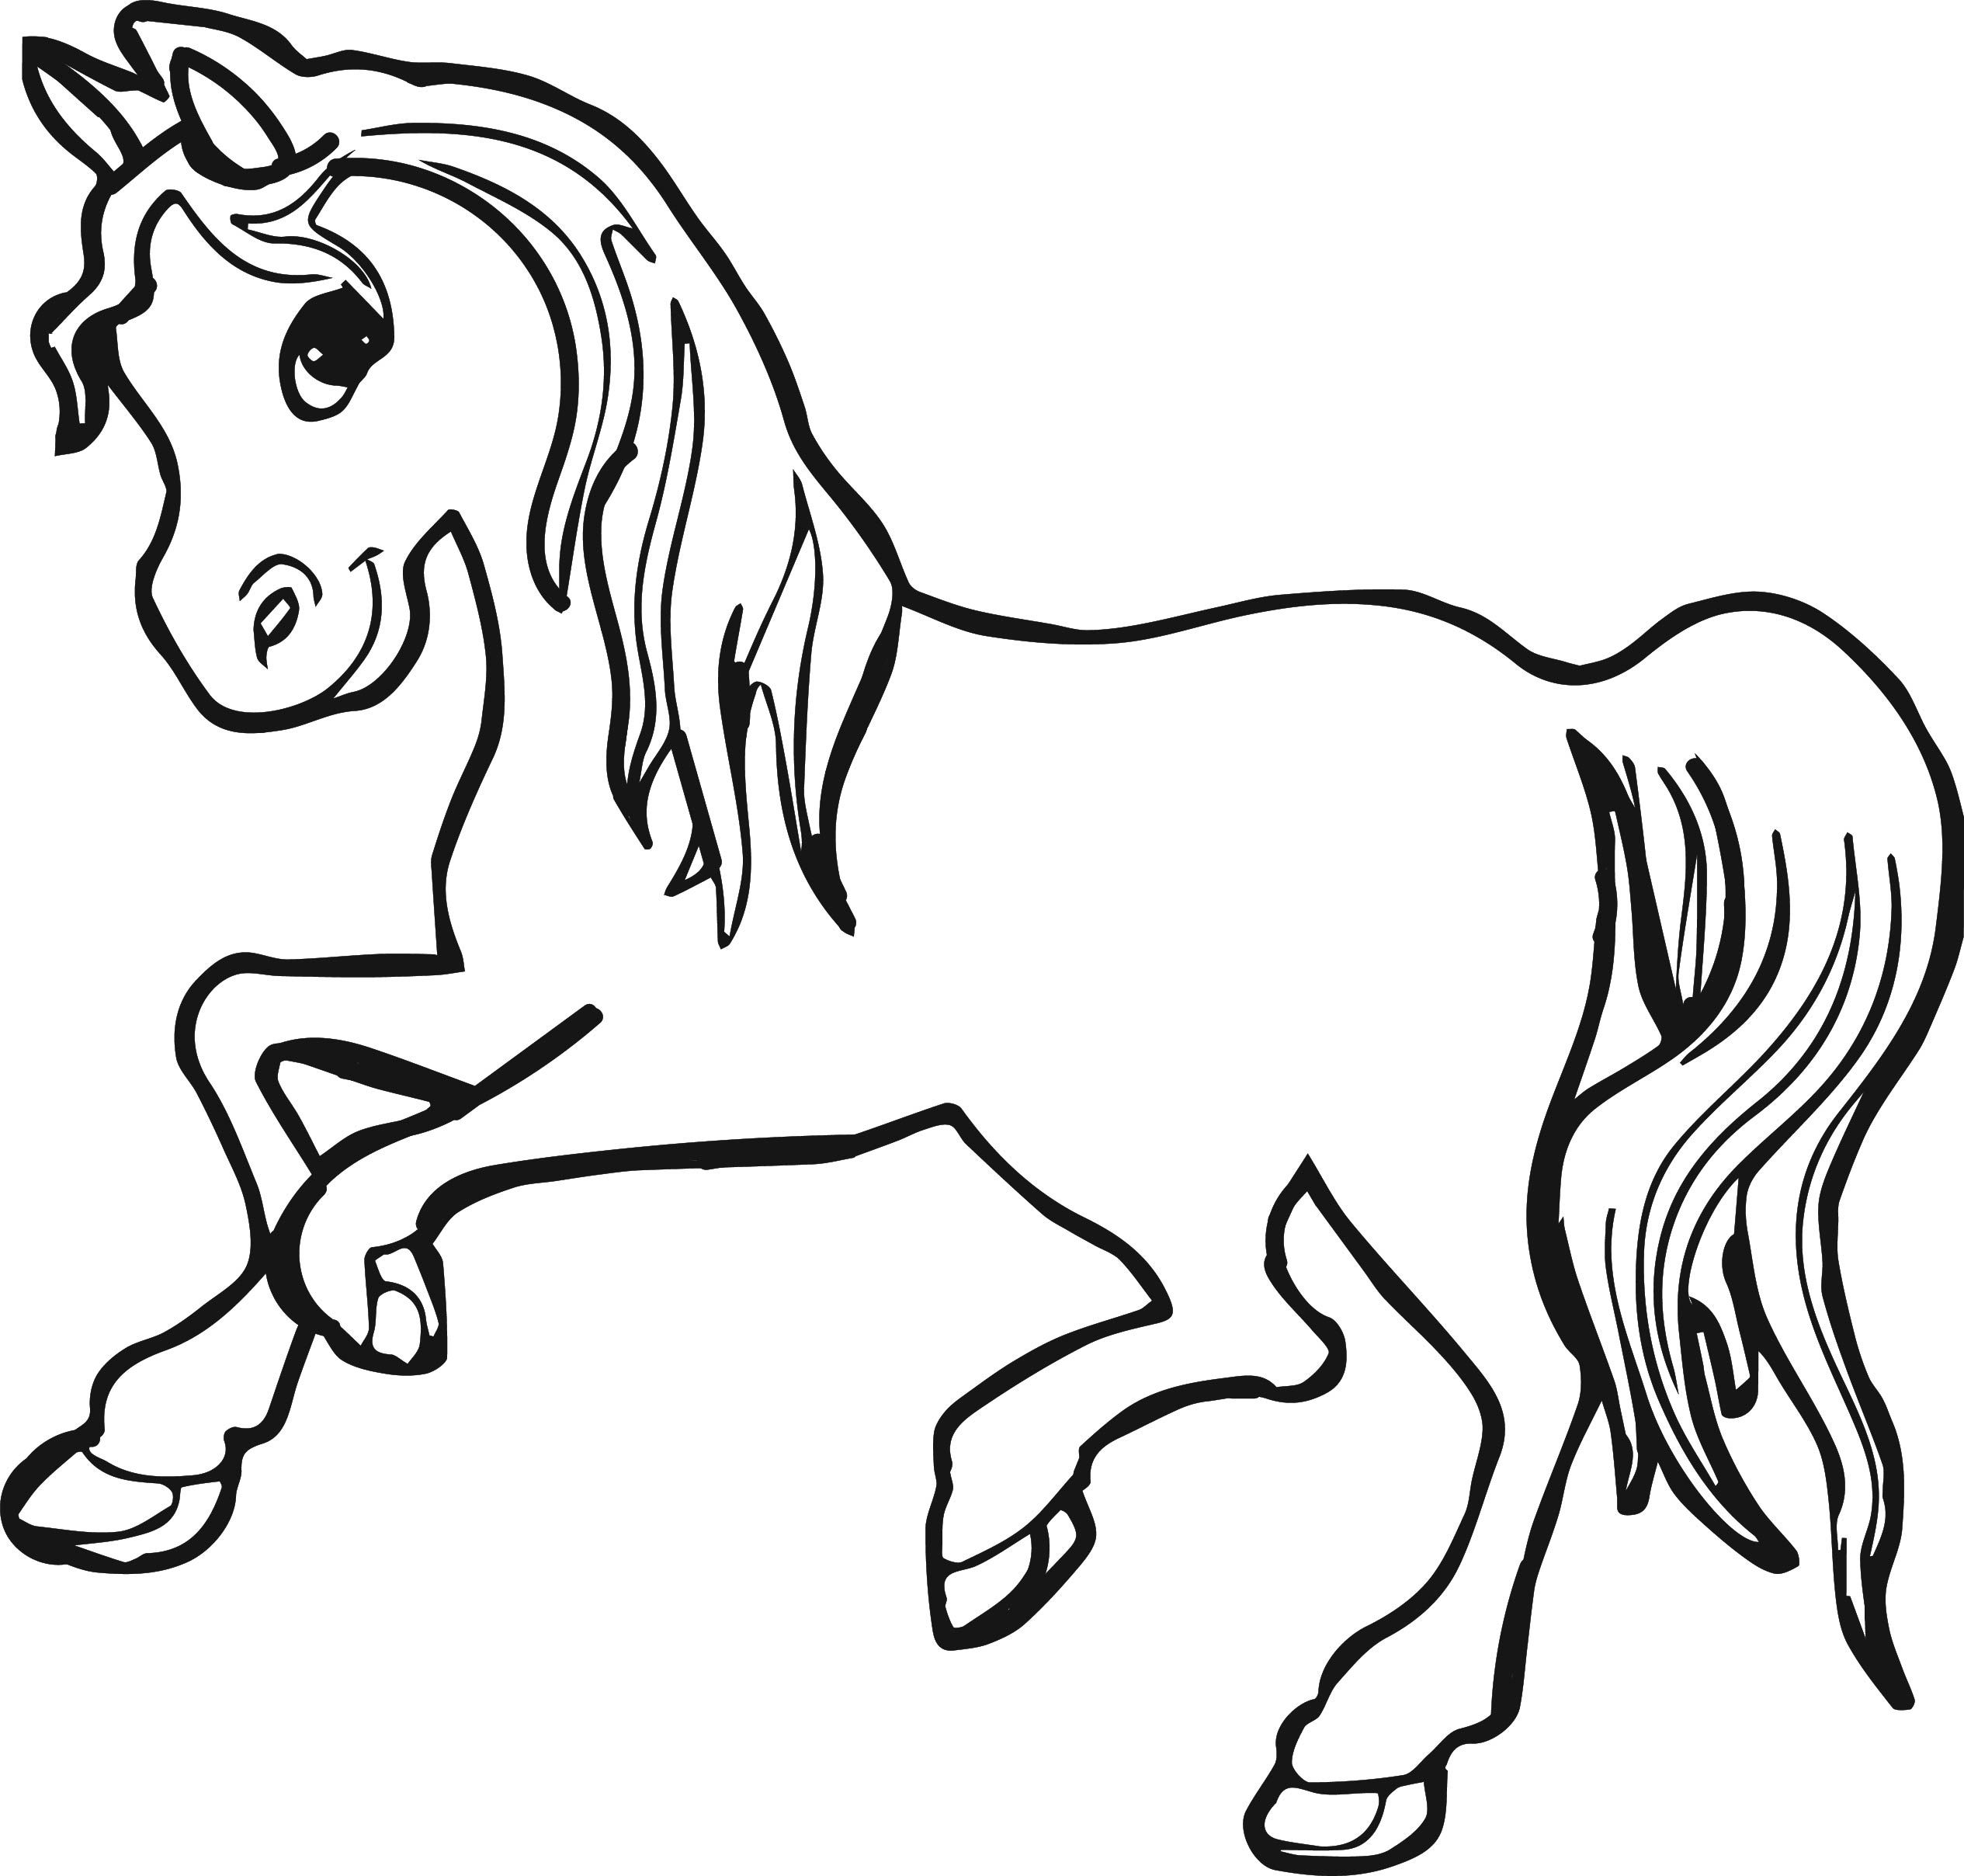

________________________________________________________________________________________________________________________________________________________________________________________________________________________________________________________________________________________________________________________________________________________________________________________________________________________________________________________________________________________________________________________________________________
а horse
а dog
а cat
а mouse
а kangaroo
а sheep
а rabbit
а bear
а frog
а tortoise
а chicken
а chimp
а cow
crawl
fly
sing
walk
talk
jump
run
swim

An elephant

